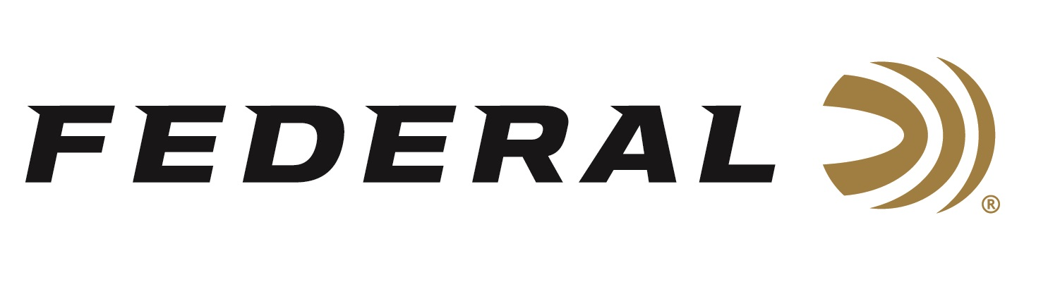

FOR IMMEDIATE RELEASE

Golden Moments on “It’s Federal Season” Podcast

ANOKA, Minnesota – May 5, 2022 – Olympic gold medalist Amber English is the guest on this episode of Federal’s “It’s Federal Season.” Guest host Julie Golob and Federal’s newest ambassador talk about Amber’s experience in Tokyo, what is next for the Olympian, and talks tips on getting started in the shotgun sports.

“Amber has a great story about her journey to Tokyo,” says guest host Julie Golob. “She highlights the entire experience of arrival, practice and walks through the event and her reaction to taking home the gold medal,” says Golob.

Golob and English continue their discussion into the Tech Talk segment and cover topics such as gun fit, shooting basics, and ammunition selection.

Episode #34 “Golden Moments”
https://www.federalpremium.com/this-is-federal/podcast/

For this episode, besides listening on the Federal Premium website or Talk North podcast network, you can also subscribe to Federal Ammunition’s YouTube channel (https://www.youtube.com/user/federalpremiumammo) and tune in for the discussion.

Federal Ammunition can be found at dealers nationwide or purchased online direct from Federal. For more information on all products from Federal or to shop online, visit www.federalpremium.com.

Press Release Contact: JJ Reich
Senior Manager – Press Relations
E-mail: VistaPressroom@VistaOutdoor.com

About Federal Ammunition
Federal, headquartered in Anoka, MN, is a brand of Vista Outdoor Inc., an outdoor sports and recreation company. From humble beginnings nestled among the lakes and woods of Minnesota, Federal Ammunition has evolved into one of the world's largest producers of sporting ammunition. Beginning in 1922, founding president, Charles L. Horn, paved the way for our success. Today, Federal carries on Horn's vision for quality products and service with the next generation of outdoorsmen and women. We maintain our position as experts in the science of ammunition production. Every day we manufacture products to enhance our customers' shooting experience while partnering with the conservation organizations that protect and support our outdoor heritage. We offer thousands of options in our Federal Premium and Federal® lines-it's what makes us the most complete ammunition company in the business and provides our customers with a choice no matter their pursuit.

